# Aim:- Prediction Using Linear Regression.

1. **Prediction Using Linear Regression.**
2. **Practical(A) code:**

x <- c(151, 174, 138, 186, 128, 136, 179, 163, 152, 131)

y <- c(63, 81, 56, 91, 47, 57, 76, 72, 62, 48)

# Apply the lm() function.

relation <- lm(y~x)

print(relation)

1. **When we execute the above code, it produces the following result –**

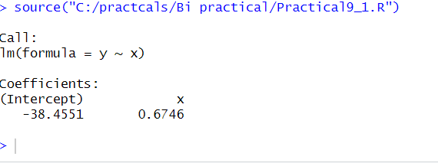

1. **Get the Summary of the Relationship.**
2. **Practical(B)Code:**

x <- c(151, 174, 138, 186, 128, 136, 179, 163, 152, 131)

y <- c(63, 81, 56, 91, 47, 57, 76, 72, 62, 48)

# Apply the lm() function.

relation <- lm(y~x)

print(summary(relation))

1. **When we execute the above code, it produces the following result-**

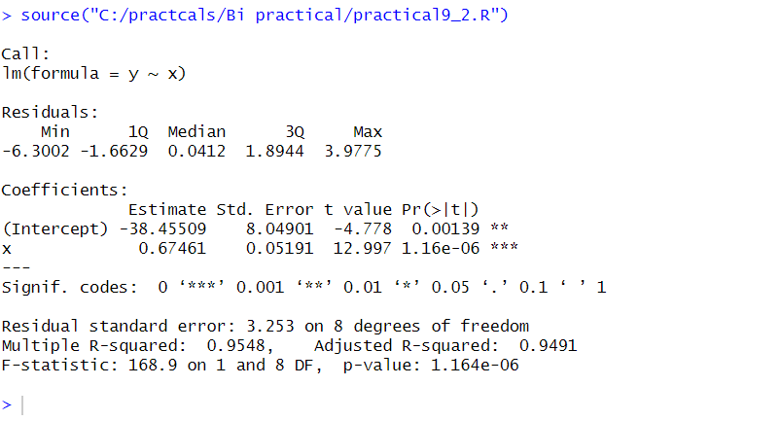

1. **Predict the weight of new persons.**
2. **Practical(C)Code:**

# The predictor vector.

x <- c(151, 174, 138, 186, 128, 136, 179, 163, 152, 131)

# The resposne vector.

y <- c(63, 81, 56, 91, 47, 57, 76, 72, 62, 48)

# Apply the lm() function. relation <- lm(y~x)

# Find weight of a person with height 170.

a <- data.frame(x = 170)

result <- predict(relation,a)

print(result)

1. When we execute the above code, it produces the following result-

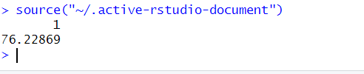

1. **Visualize the Regression Graphically.**
2. **Practical(C)Code:**

# Create the predictor and response variable.

x <- c(151, 174, 138, 186, 128, 136, 179, 163, 152, 131)

y <- c(63, 81, 56, 91, 47, 57, 76, 72, 62, 48)

relation <- lm(y~x)

# Give the chart file a name.

png(file = "linearregression.png")

# Plot the chart.

plot(y,x,col = "blue",main = "Height & Weight Regression",

abline(lm(x~y)),cex = 1.3,pch = 16,xlab = "Weight in Kg",ylab = "Height in

cm")

# Save the file.

dev.off()

1. **When we execute the above code, it produces the following result-**

